What Made Korea’s Rapid Growth Possible?

By Jungho Yoo

ISBN 9781138801264
Published March 6, 2020 by Routledge

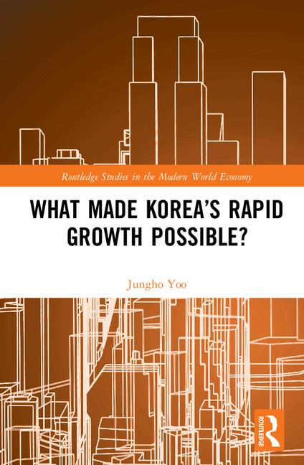

<Book Description>
Korea’s experience of rapid economic growth represents both hope and a challenge to many developing countries. The conventional wisdom inside and outside Korea has been that the government’s policies such as export promotion, industrial targeting, and so on, made the rapid growth possible.

This book investigates the effects of the policies and concludes that Korea’s growth experience does not corroborate the view. Rather, it points to the tremendous growth in size of the world market as an important factor that has been overlooked in the discussion of nations’ economic growth in the post-World War II era. It was roughly 100 times bigger in the early 1960s than it was in the middle of the First Industrial Revolution. The potential "gains from trade" were that much greater; while the Korean economy had not been realizing the potential gains, it began to as soon as a major reform of the foreign exchange system in 1961 removed the impediments to foreign trade. Explosive export expansion and rapid growth of the economy immediately followed. The “Korean Miracle” may be better understood as a process whereby the economy realized its huge potential.

<Table of Contents>
1 The economy and policies in the 1950s
2 Rapid export expansion in the 1960s and 1970s
3 The transformation of the Korean economy
4 Industrial policy in the 1970s
5 The world market size and the pace of industrialization
6 Concluding remarks

<Author Biography>
Jungho Yoo is Visiting Professor at the Korea Development Institute (KDI) School of Public Policy and Management, South Korea. He was previously Fellow at the KDI.

